SUPPLIER PREQUALIFICATION BIDDING INSTRUCTIONS
- Click on the following link e.tendersure.africa you will be prompted to login to the Tendersure platform.
  - New User Without an Account on Tendersure
Click the [Register Now] button and key in your Company and user details. Please ensure that the email provided is correct as it will be your username and form of communication with the Tendersure portal.
After account registration, you will receive an Account Activation email with your log in credentials. Check your email, click on the activation link and log in using the provided credentials.
You will then be directed to the Dashboard, and you will see the supplier prequalification of your interest.
  - Existing User With an Account on Tendersure
If you already have an account on Tendersure, proceed to login and you will be redirected to the Dashboard.
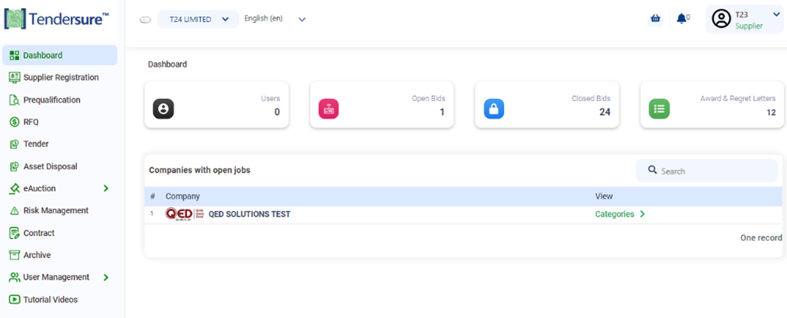
- Click [Categories] for your company of interest and then click on the [Supplier Prequalification] tab. Read the [Helpful Pointers] provided and search for the category you want to participate in.
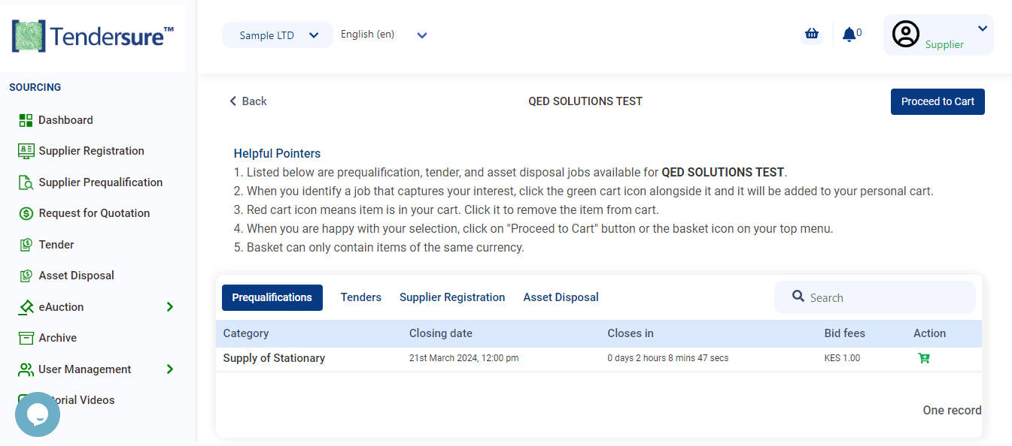

- Select the category by clicking on its green shopping cart icon to add the category to your cart. Next, click [Proceed to Cart] and select your payment method.
- After making payment, for a supplier prequalification click [Supplier Prequalification] on the side navigation menu and you will see the categories that you have paid for. Click the [Bid] button then click on [Participate] and bidding page with questions will appear. Complete each section highlighted in blue at the top of the page.
- Click [Next] at the end of every section to navigate to the next section.
- After completion of your bid, click on the [Submit] button in the declaration section and you will receive an email from the Tendersure system confirming receipt of your bid and a report of all your responses.
- If you wish to amend you bid before the job closes, on logging in, click the on the side navigation menu and click the [Update] button of the job you want to amend. On submission of the updated responses, you will receive an email from the Tendersure system confirming receipt of your updated bid.

Should you have any queries, please call +254 709 557 000 or email help@tendersure.africa

Best Regards,
Tendersure™ Team

